ROUTING ALGORITHMS
The routing algorithm is that part of the network layer software responsible for deciding which output line an incoming packet should be transmitted on. If the network uses datagrams internally, this decision must be made anew for every arriving data packet since the best route may have changed since last time. If the network uses virtual circuits internally, routing decisions are made only when a new virtual circuit is being set up. Thereafter, data packets just follow the already established route. The latter case is sometimes called session routing because a route remains in force for an entire session
1) Distance Vector
A distance vector routing algorithm operates by having each router maintain a table (i.e., a vector) giving the best known distance to each destination and which link to use to get there. These tables are updated by exchanging information with the neighbours. Eventually, every router knows the best link to reach each destination.
The heart of distance-vector routing is the famous Bellman-Ford equation. This equation is used to find the least cost (shortest distance) between a source node, x, and a destination node, y, through some intermediary nodes (a, b, c, . . .) when the costs between the source and the intermediary nodes and the least costs between the intermediary nodes and the destination are given. The following shows the general case in which Dij is the shortest distance and cij is the cost between nodes i and j.
Dxy = min{(cxa + Day), (cxb + Dby), (cxc + Dcy), …}
In distance vector routing, each router maintains a routing table indexed by, and containing one entry for each router in the network.
This entry has two parts:
- the preferred outgoing line to use for that destination
- an estimate of the distance to that destination.
The distance might be measured as the number of hops or using another metric. The router is assumed to know the ‘‘distance’’ to each of its neighbours. If the metric is hops, the distance is just one hop. If the metric is propagation delay, the router can measure it directly with special ECHO packets that the receiver just timestamps and sends back as fast as it can.
Bellman-Ford Equation
Information kept by DV router
  - Each router has an ID
  - Associated with each link connected to a router, there is a link cost (static or dynamic).
  - Intermediate hops
Distance Vector Table Initialization
  - Distance to itself = 0
  - Distance to ALL other routers = infinity number.
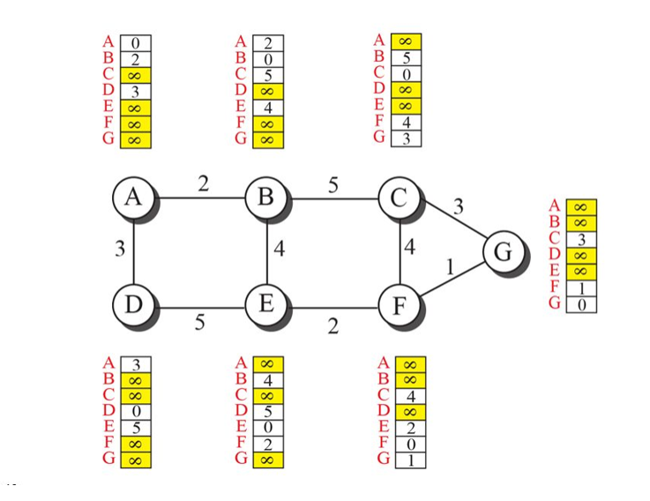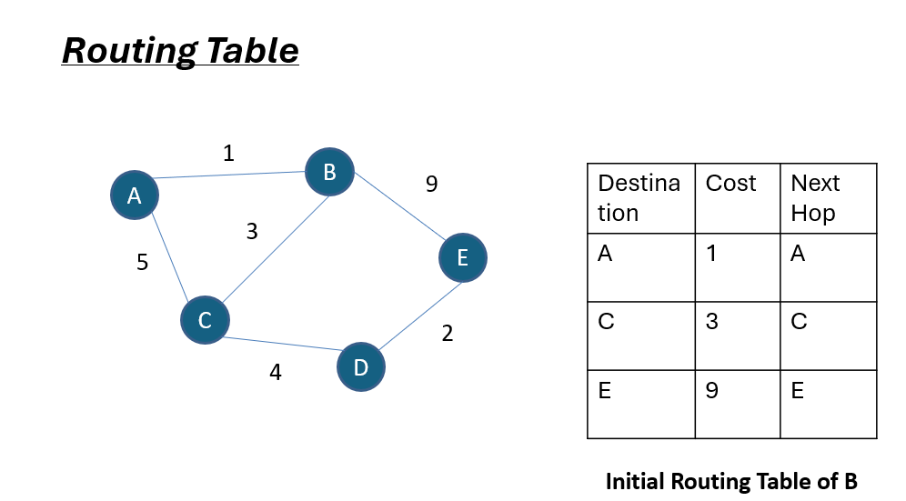
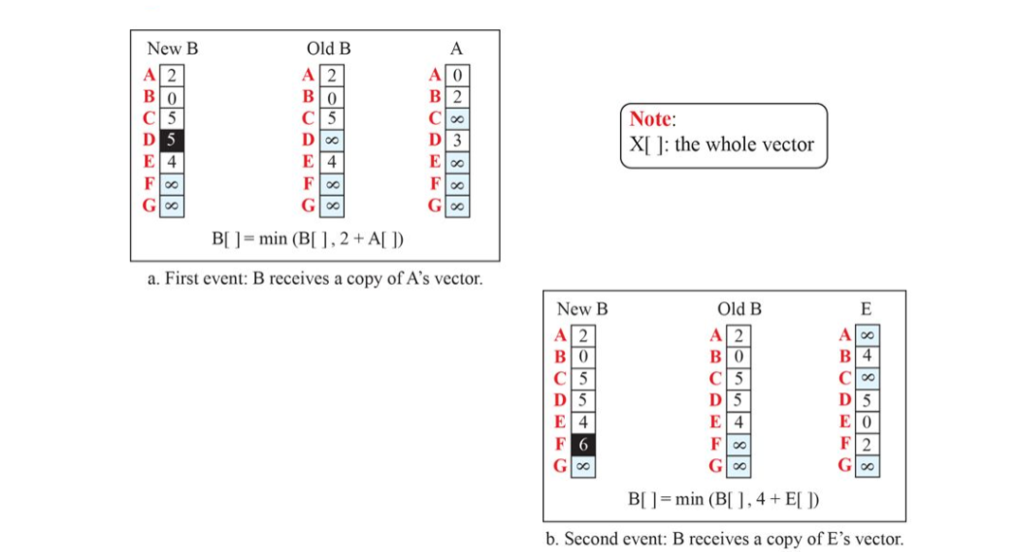
2) Link state routing
Distance vector routing had a primary problem that caused its demise was that the algorithm often took too long to converge after the network topology changed (due to the count-to-infinity problem). Consequently, it was replaced by an entirely new algorithm, now called link state routing. Variants of link state routing called IS-IS and OSPF are the routing algorithms that are most widely used inside large networks and the Internet today. The idea behind link state routing is fairly simple and can be stated as five parts. Each router must do the following things to make it work:
1. Discover its neighbours and learn their network addresses.
2. Set the distance or cost metric to each of its neighbours.
3. Construct a packet telling all it has just learned.
4. Send this packet to and receive packets from all other routers.
5. Compute the shortest path to every other router.
In effect, the complete topology is distributed to every router. Then Dijkstra’s algorithm can be run at each router to find the shortest path to every other router.
Least-Cost Trees
Created using Dijkstra’s Algorithm.
Steps:
  - The node chooses itself as the root node of the tree.
  - The node selects one node, among all nodes in the tree, which is closest to the root, and adds this to the tree. After this node is added to the tree, the cost of all other nodes not in the tree needs to be updated because the paths may have been changed.
The node repeats step 2 until all nodes are added to the tree.
Link state routing is widely used in actual networks, so a few words about some example protocols are in order. Many ISPs use the IS-IS (Intermediate System-Intermediate System) link state protocol . It was designed for an early network called DECnet, later adopted by ISO for use with the OSI protocols and then modified to handle other protocols as well, most notably, IP. OSPF (Open Shortest Path First) is the other main link state protocol.
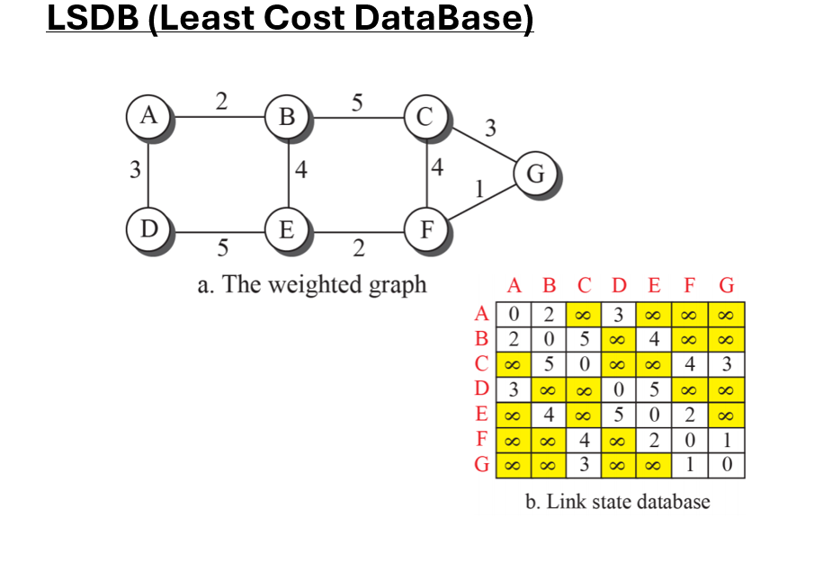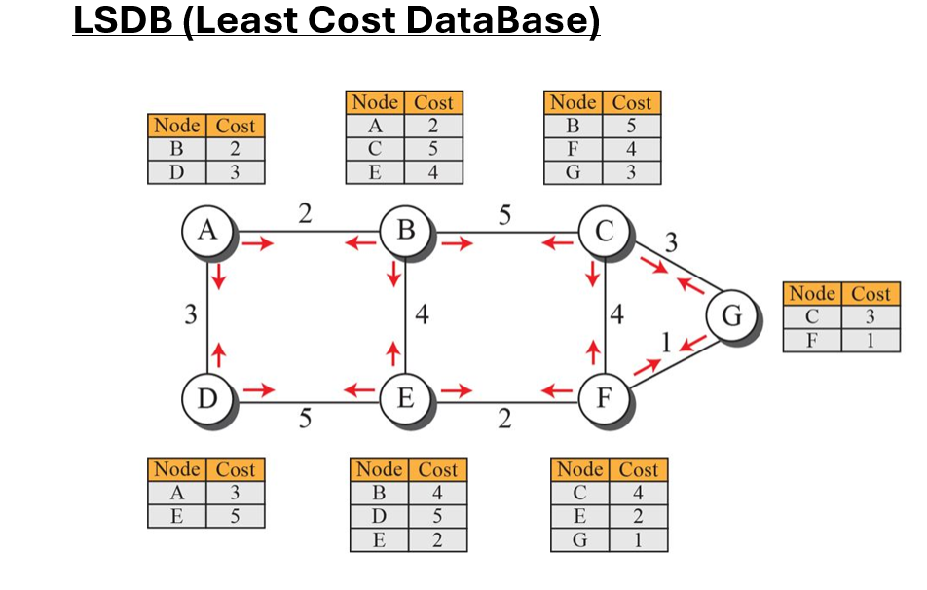
3) PATH VECTOR ROUTING
In path vector routing the best route is selected by the source using the policy it imposes on the route. That means, the source can control the path. Path-vector routing does not have the drawbacks of LS or DV routing because it is not based on least-cost routing. Although path-vector routing is not actually used in an internet, and is mostly designed to route a packet between ISPs.
in path-vector routing, the path from a source to all destinations is also determined by the best spanning tree. The best spanning tree, however, is not the least-cost tree; it is the tree determined by the source when it imposes its own policy. If there is more than one route to a destination, the source can choose the route that meets its policy best. A source may apply several policies at the same time. One of the common policies uses the minimum number of nodes to be visited (something similar to least-cost). Another common policy is to avoid some nodes as the middle node in a route.
A spanning tree is a subset of the network that includes all the routers but contains no loops. Sink trees are spanning trees. If each router knows which of its lines belong to the spanning tree, it can copy an incoming broadcast packet onto all the spanning tree lines except the one it arrived on. This method makes excellent use of bandwidth, generating the absolute minimum number of packets necessary to do the job.
